**Arrays**  
* We’re gonna be talking about a way to store multiple values of the same type.  
* Array is a data structure that allows you to store sequence of values, that are all of the same type.  
* This works for all primitive types and even Objects like the String.  
* **type[]** name = **new type[x]**.  
* For example: **int[] myArray = new int[10]**.  
* The number [x] is the number of slots or separate elements that we can assign to this array.  
* How do we save values?  
* myArray[5] = 50.  
* How do we access values?  
* myArray[5].  
* For assigning the values there’s a shortcut that Java gives us, if we know ahead of time the values we want to actually save in an array, it’s only applicable the first time we create that array:  
* int[] myArray = {1,2,3,4,5,6,7,8,9,10}.   
* The size of the array is based on how many elements you passed this way.  
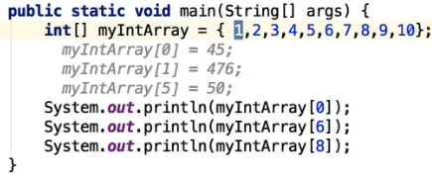  
* There’s a third way to initialize an array - we can use a FOR LOOP:  
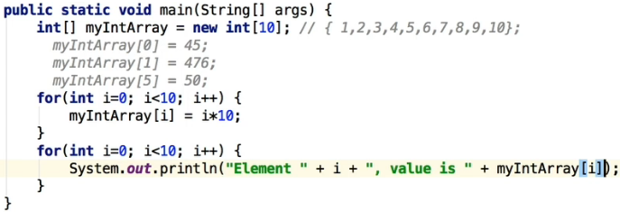  
* It’s a great way to initialize it if you’ve got some sort of formula that you know ahead of time that you can actually use to assign to the particular element in the array.  
* For the FOR LOOP you can use a property/field of an Array => **.length**.  
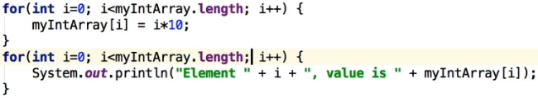  
* We can also create a method for it:  
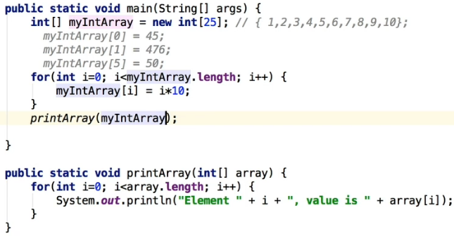

* Let’s see a real use example:  
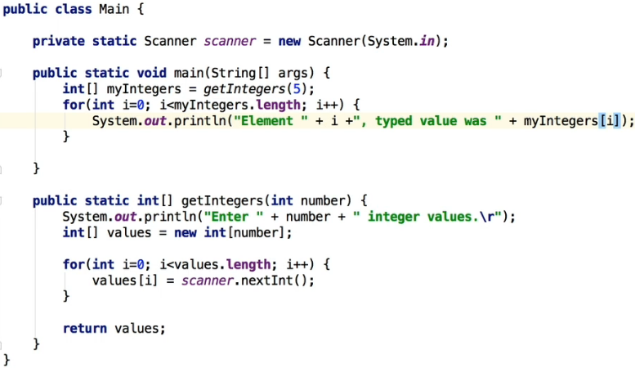  
* **/r** takes you to the beginning of the next line.  
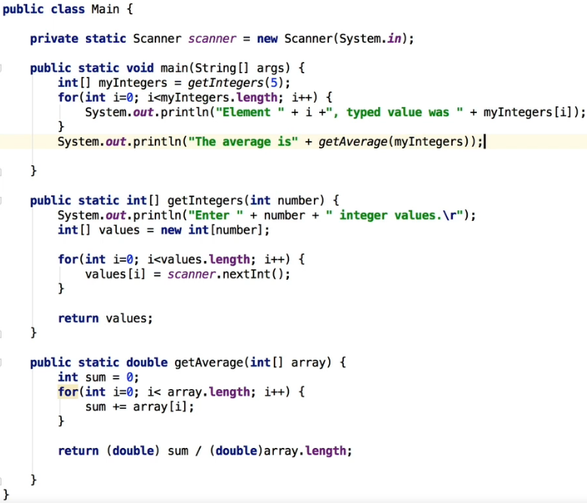  
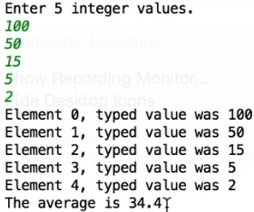

**Arrays (Challenge Exercise)**  
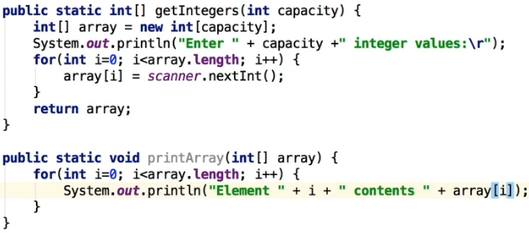  
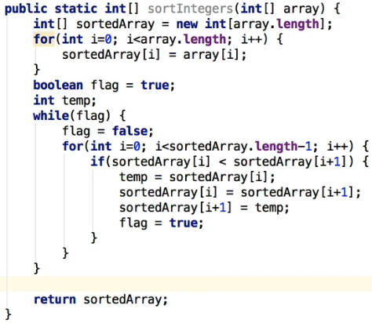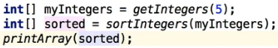  
* The for loop in the sortIntegers() creates a copy of the array we pass as an argument.  
* There’s actually a number of built-in ways to create a copy of an array.  
* More and more as you become more familiar with Java, you’ll be wanting to use some of the features that are built into Java because it saves you a lot of time, it’s less code, and you’re actually using code that has been heavily optimized, is much faster and it’s just less code to debug.  
* **Array.copyOf(array, array.length)**  
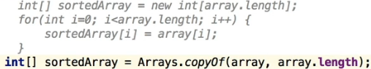  
* It effectively takes a copy of the array, the length specifies how many elements to copy.

**Arrays Recap**  
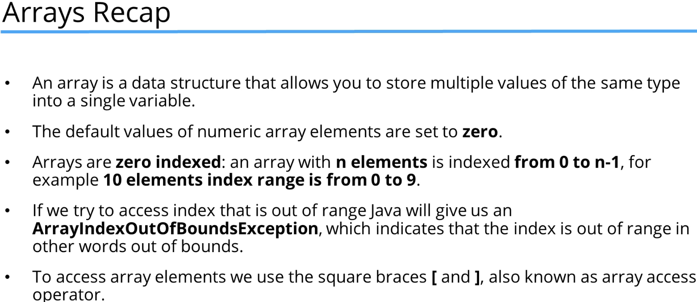

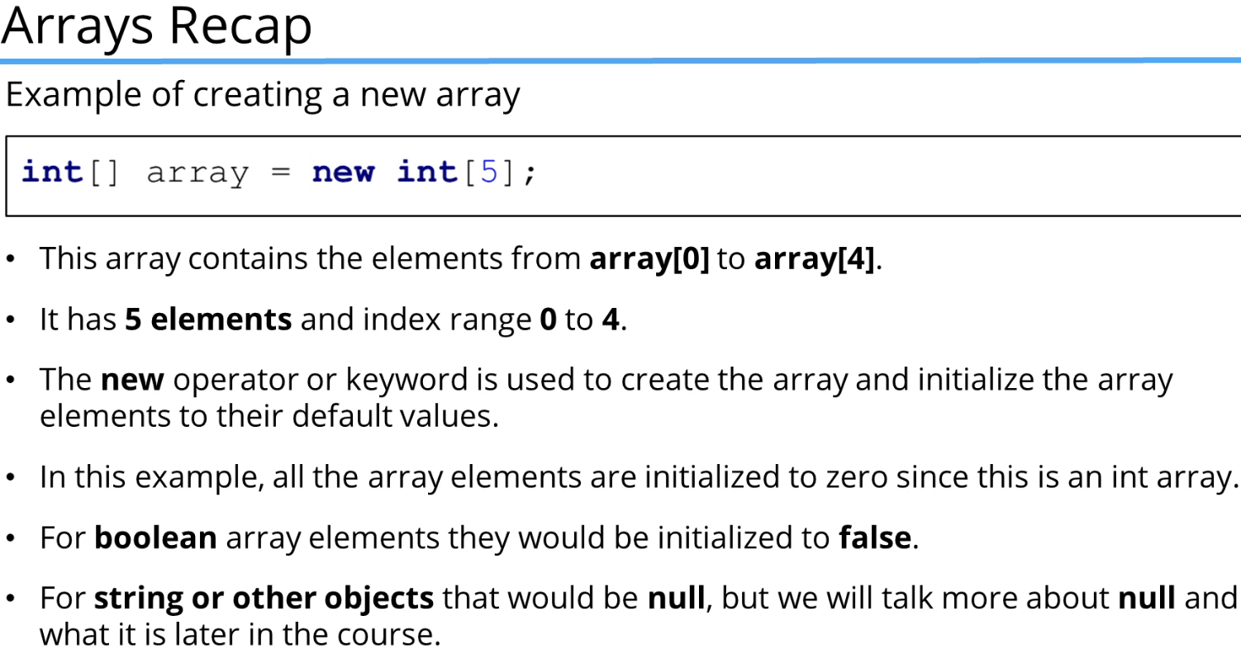  
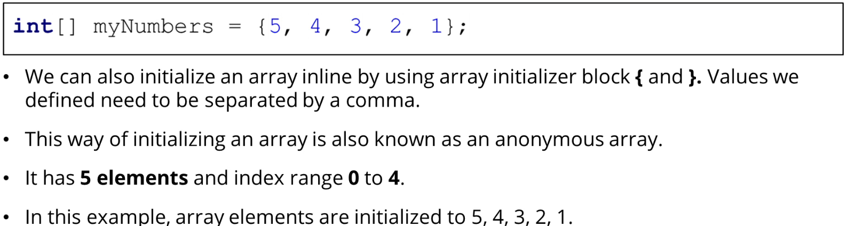  
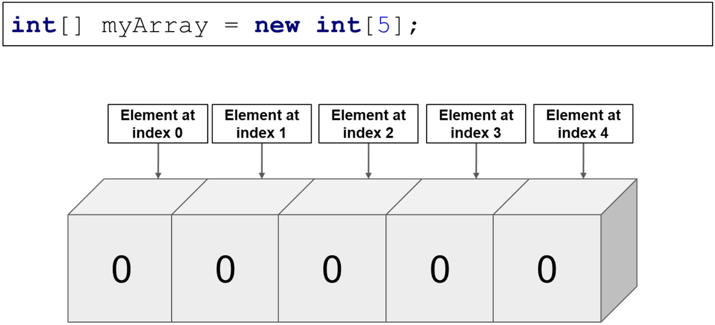  
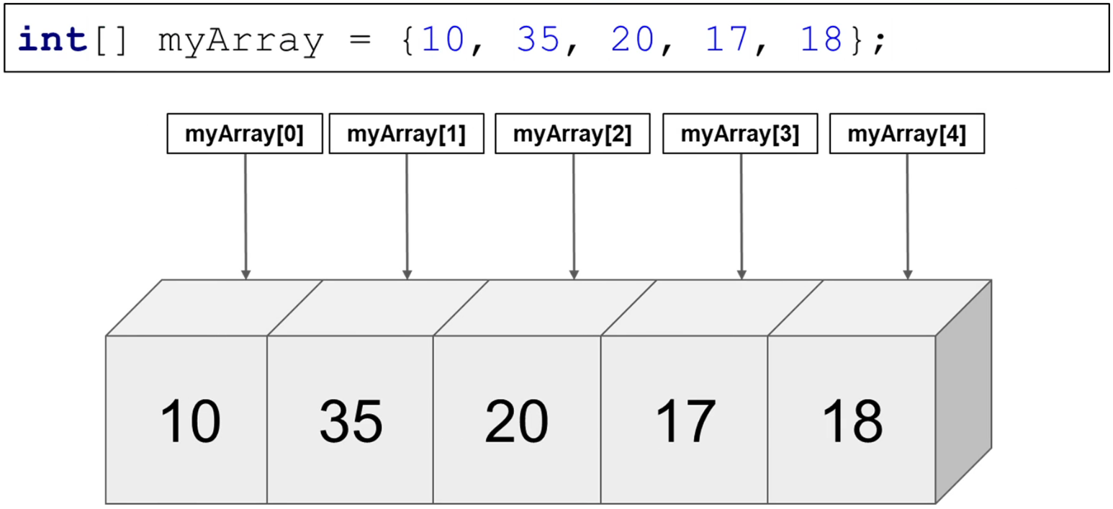  
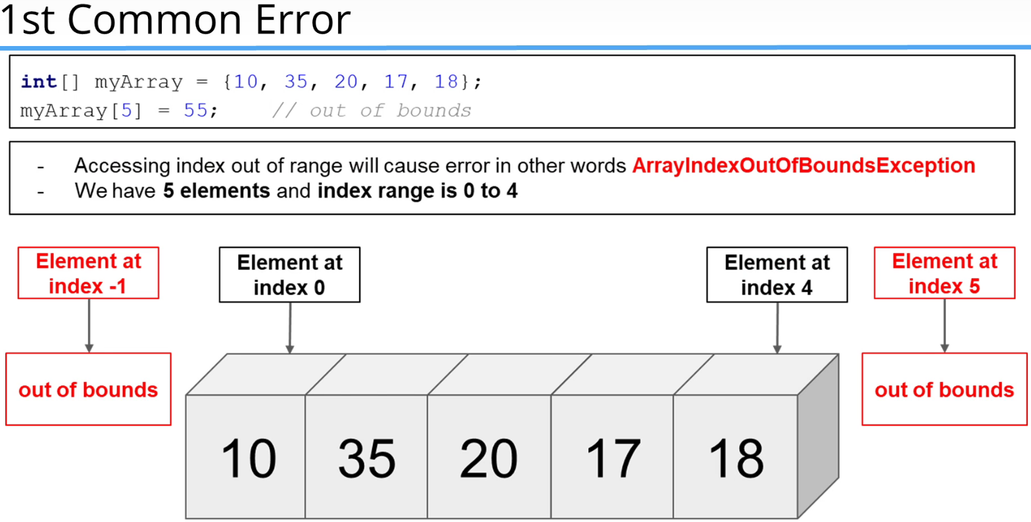  
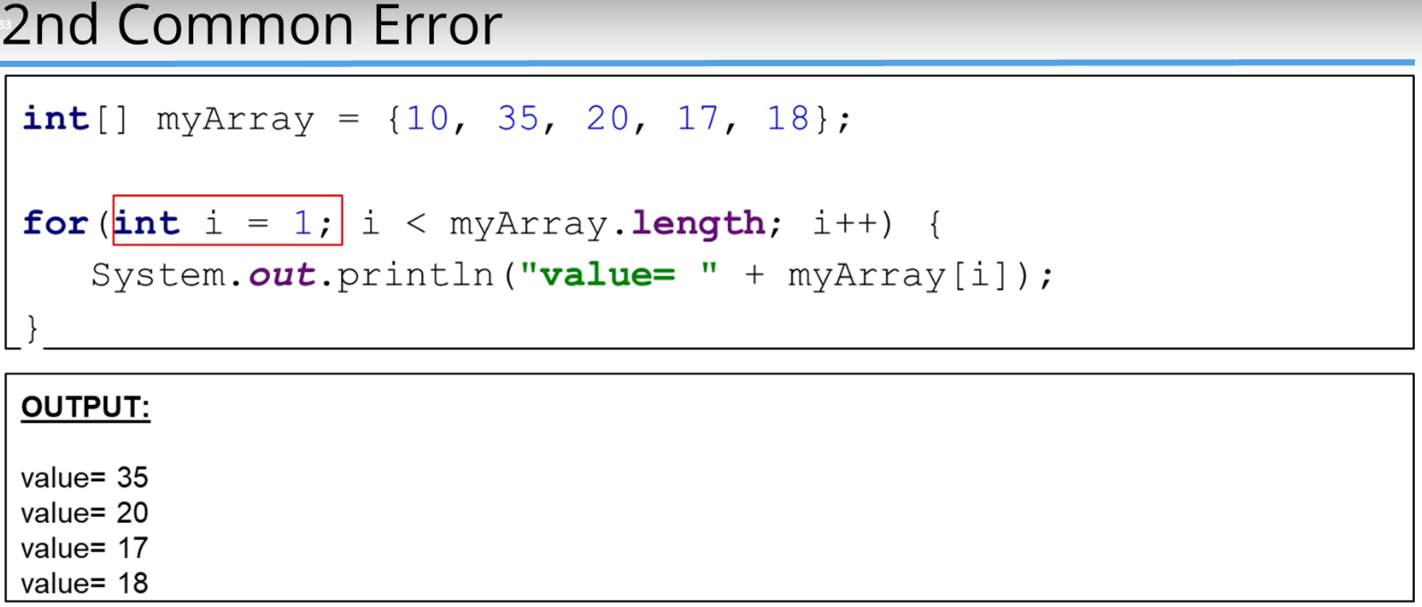  
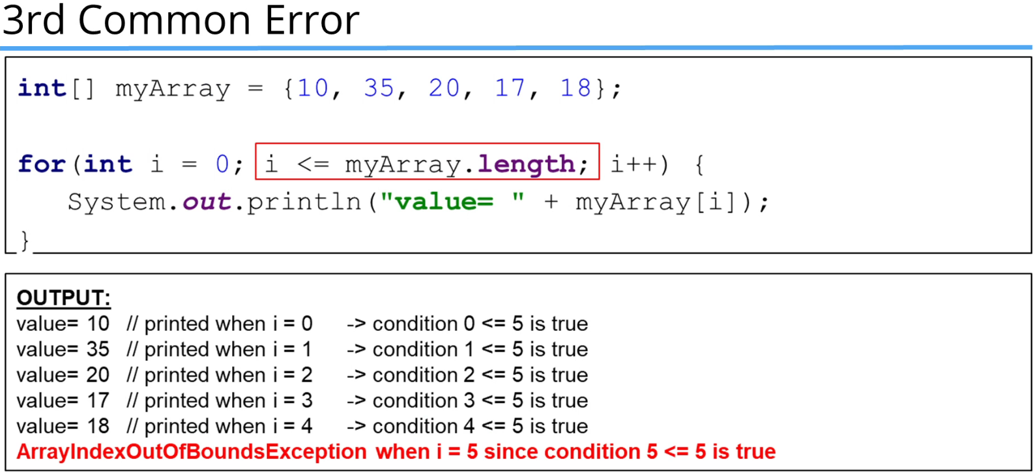

**References Types vs Value Types**  
* **All the Primitive Types are Value Types**. They hold a value.  
* **An Array and a String are Reference Types**. They hold a reference.  
* When we created an int variable, a single space in memory is allocated to store the value and that variable directly holds a value. If you assign it to another variable, the value is copied directly and then both variables work independently, they each have their own copy of a specific value.  
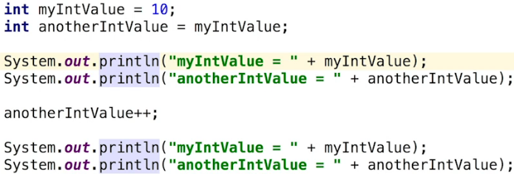 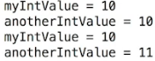

* Reference types like Array or Classes work differently.   
* When you see the `new` keyword, that means we’re creating a new Object.  
  
* We have a reference myIntrArray.   
* Reference Types are used by a Reference so it holds a reference/address to the Object but not the Object itself.  
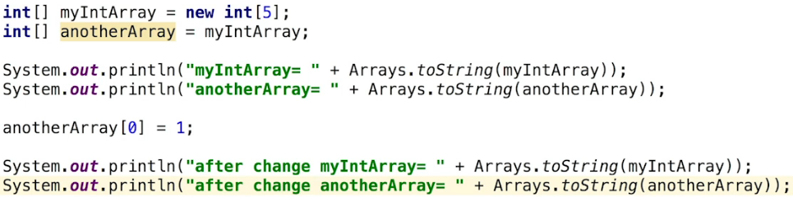  
* So the variable myIntArray holds a reference/address to an Array in memory.  
* With reference types we’re using a reference to control the Object in memory.  
* We’re declaring another reference to the same Array in memory.  
* Both myIntArray and anotherArray hold the same address.  
* One way to know it’s a reference type is the `new` operator because that creates a new Object in memory.  
* **Arrays.toString(myArray)** joins multiple Strings or Objects into a string using a comma as a separator. So it’s gonna convert every element in the array to a String and then return a new String where every element is separated.  
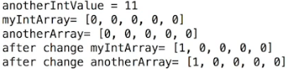  
* Reference Types represent the address of the variable rather than the data itself.  
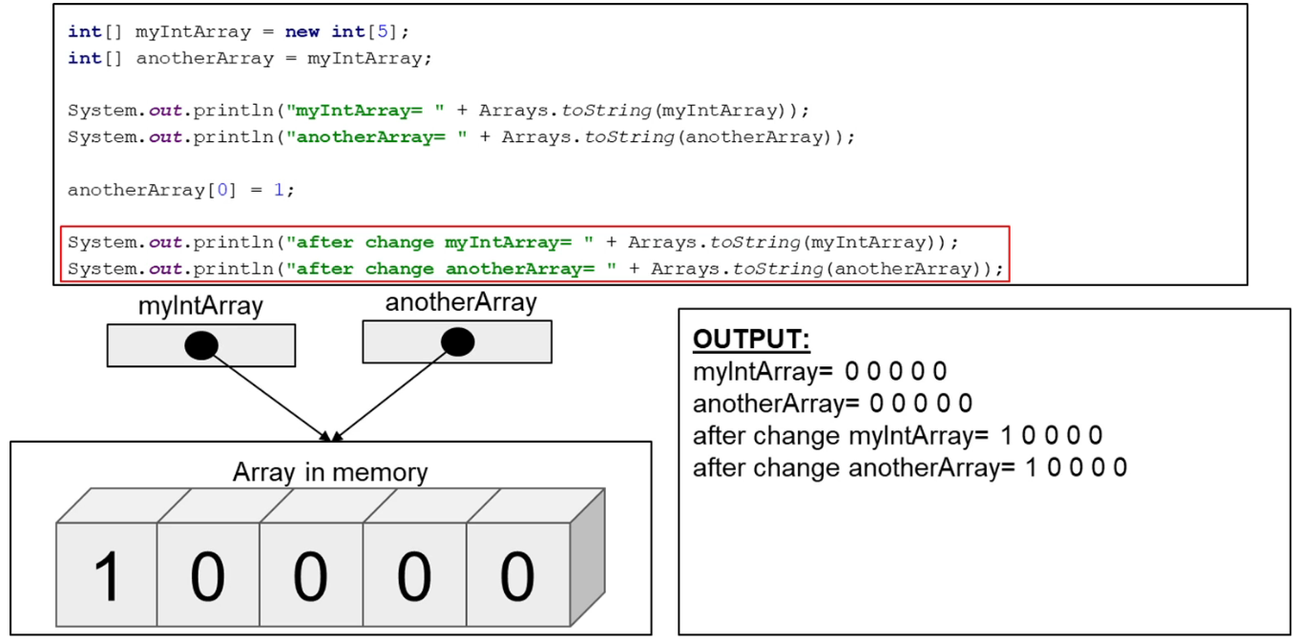  
* The same behavior happens when we pass Reference Types to methods.  
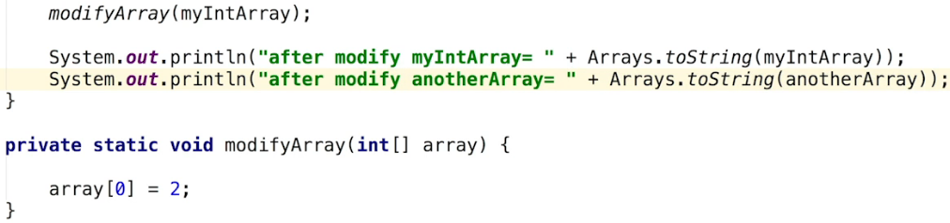  
* **Here the parameter is the 3rd reference to this array**.  
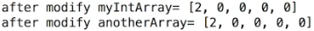  
* We can dereference = reinitialize the array that we received by our parameter to our method.  
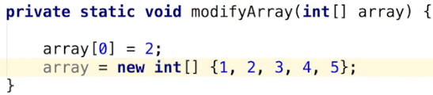  
* In this case we’re creating a new Array, it now points to a different Array since we used the `new` keyword.

**Minimum Element Challenge**  
* By setting the Scanner as a STATIC field, we needed to do that so that the other STATIC methods like the existing main method and the readIntegers method we’re going to create - they’ll be able to access this field directly in other words the STATIC methods can use Scanner without creating separate instances of that class.  
* Now since we’ve already got this one main class, the methods in main can also be STATIC and should be and you can see that by default the main method has the STATIC keyword there.  
* Additionally I’ve sent the Scanner to PRIVATE so that other classes can’t access it, even though this doesn’t necessarily matter for this program since we don’t have any other classes but it’s a good idea to keep all fields PRIVATE to Encapsulate the data.  
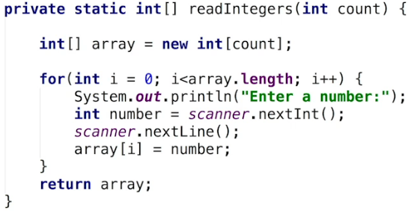  
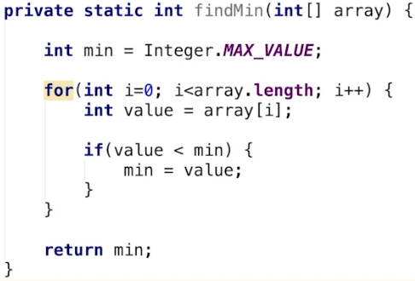  
* You can either use a MAX_VALUE or the 1st element of the array.  
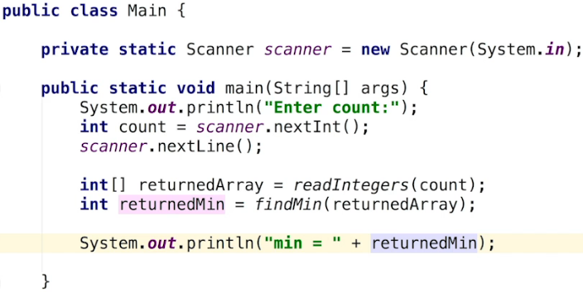

**Reverse Array Challenge**  
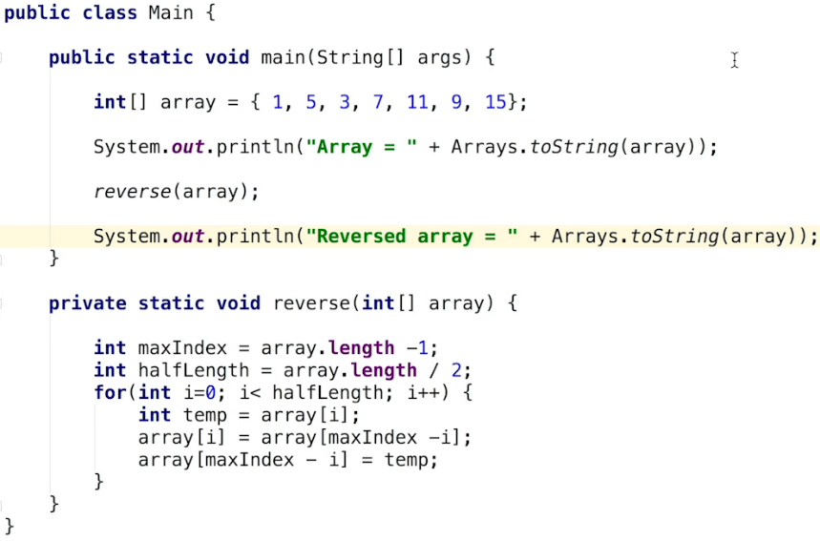* One thing we haven’t talked about is **Resizing** an **Array**.  
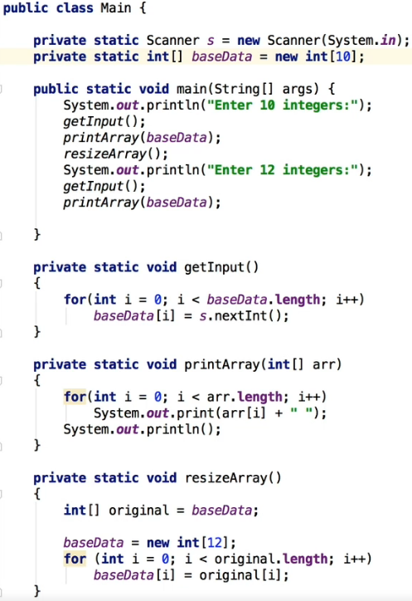

* You save the original Array into another variable.  
* You then initialize the variable with a new Array with a different size.  
* Then you loop through the original Array and copy the original values into the new Array.  
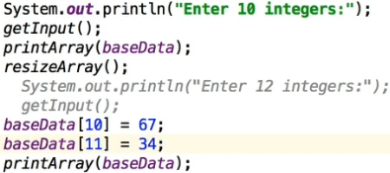  
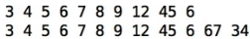  
* You can see that would get quite unwieldy if you had continually resize that array. It would be quite tedious to implement, all the time continually having to copy all those elements, with lots of elements it wouldn’t be very productive to do that.  
* So there has to be a better way of actually resizing Arrays.  
* So we’re gonna now talk about the concept of a List and an ArrayList

**List and ArrayList Part 1**  
* List is another way of looking at an Array effectively because you can arguably say that an Array is a List in that it’s a sequence of numbers.  
* **ArrayList** inherits from an AbstractList.  
* **ArrayList is a resizable Array**. It handles the resizing automatically. It not only maintains a size but also the capacity - the amount of memory that is reserved. And as elements are added to an ArrayList, its capacity grows automatically. So you don’t need to worry about any of that resizing, it all actually happens automatically and that’s a cool thing about ArrayLists.  
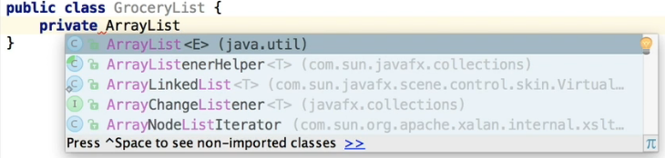  
* It’s got this <E> and what that means is with an ArrayList it’s a little bit different in that we’re not defining the type because ArrayLists can hold Objects so we need to actually tell it now what type of Object we want it to store <type-of-object>.  
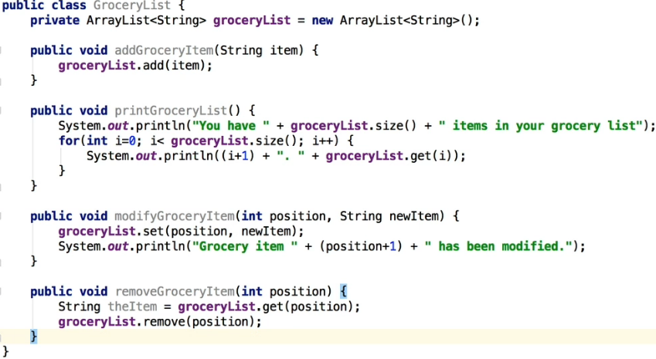  
* It tells Java: okay you’re creating an ArrayList and the elements that are in the ArrayList in this case are going to be of type String.  
* **The reason in has the parenthesis () is that the ArrayList is actually a Class, not a primitive type**.  
* So it’s calling an empty constructor.  
* **.addItem(item)** => adds an item into the ArrayList and it has all the functionality to actually determine where to save it, the amount of space to allocate and so on, that’s abstracted away from you, you don’t need to worry about that.  
* **.size()** => **returns how many elements are stored in the ArrayList**.  
* **.get(i)** => **returns i-th element from the ArrayList**.  
* **.set(position, newItem)** => **replaces the item in that position**.  
* **.remove(position)** => **removes the item in that position**.

**ArrayList Part 2**  
* To find an item we can of course use a for loop and compare it but especially when you’re using built-in Java classes like the ArrayList, you want to see whether there’s an ability to shortcut some functionality and to do things for you.  
* Code like this that’s built-in in Java has been optimized so you really want to use their functionality wherever it’s possible.   
* **.contains(item)** => **returns true/false if it can find the searched item**.  
  
* **.indexOf(item)** => **returns the index/position of the item or -1 if the item isn’t found**.  
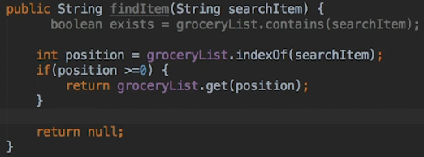

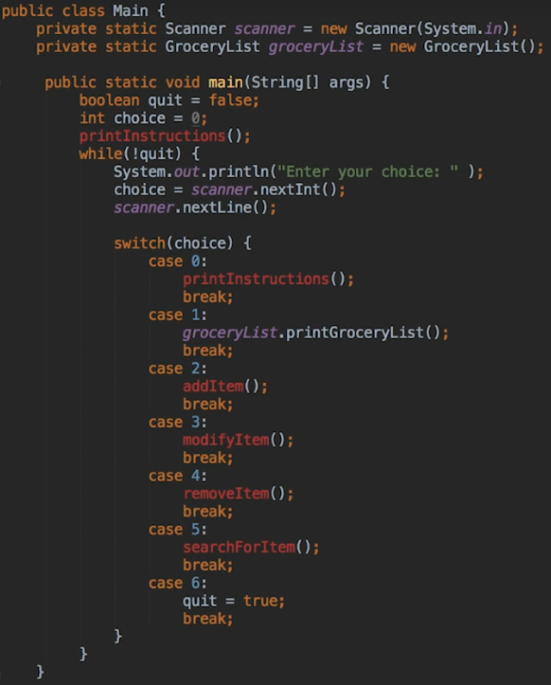  
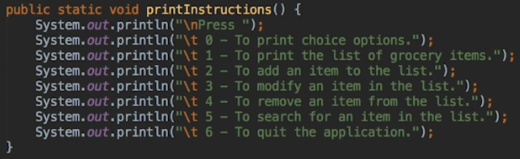  
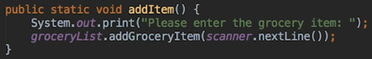  
* There’s -1 because the user will enter 1 as the first element while ArrayList starts with 0.  
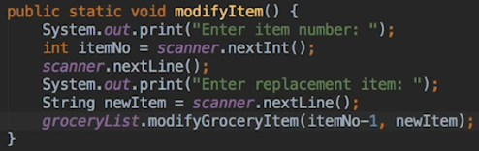  
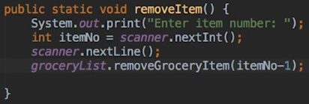  
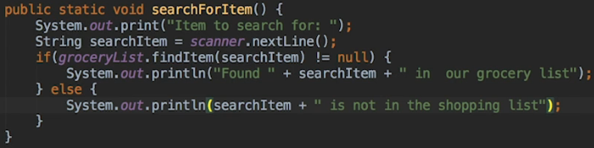

* **The -1 deduction could be done in the GroceryList class instead but you generally wouldn’t want to do that because it’s probably better practice in this case to be updating the main class because in the class itself you’d count with the correct number**.  
* One thing I want to point out is that we didn’t have to use positions, what you might want to do in an ideal scenario here is not force the user to have to specify position but to actually use something along the lines of what we’ve done with findItem() to find the position and delete it that way.

**ArrayList Part 3**  
* Now let’s change the methods so that we don’t require the client (the program that’s using the GroceryList class) to have to enter the position of the item. We should really be creating a class in this case the GroceryList class that’s self-contained and leave it to handle the actual element numbers.  
* Let’s change the findItem() so that it returns the index.  
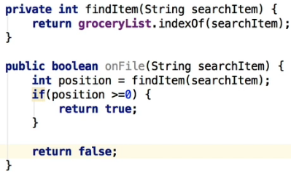  
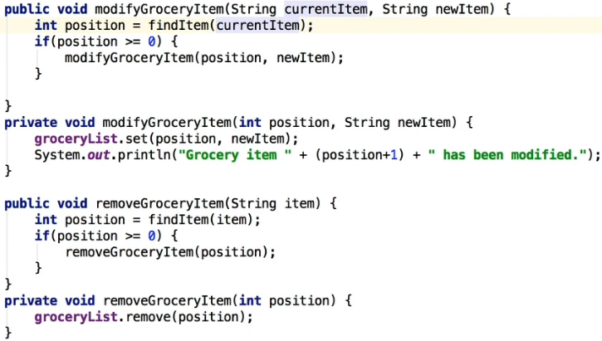  
* **Now we don’t want the older versions of the methods to be public anymore, we want it to be our internal methods, not accessible to anything but the internal workings of the GroceryList class**.  
*In Main.Java:  
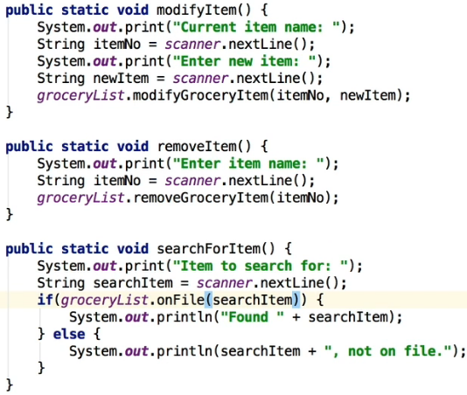  
* Now I want to show you a couple of other ways to access Arrays.  
* Let’s add a getter.  
* GroceryList.java:  
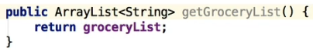  
* Main.java:  
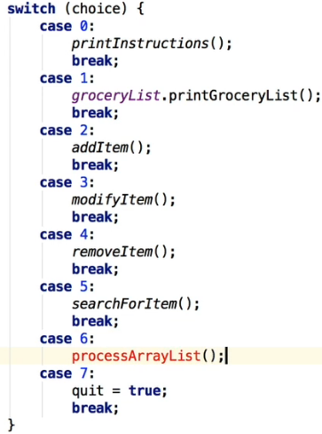  
* I want to show you some other ways that you can copy one ArrayList to another ArrayList because there could be situations where we’d want to do that.

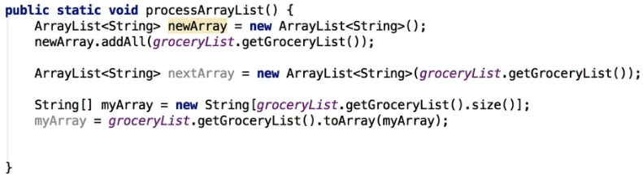  
* It takes the contents that are in GroceryList, that’s one way of adding the entire content to a new ArrayList.  
* **.addAll()**  
* There’s another quick way of doing it.  
* If you know the ArrayList that you want to copy at the point that you’re creating the new ArrayList, you can actually just put in that ArrayList.  
* These are the types of things that you’ll want to do wherever possible - you want to try to find the Java shortcuts to your code, so you don’t have to do this sort of stuff and creating all this extra code that’s unnecessary.  
* Lastly, there’s 1 more way of doing it - if for some reason you want to take the contents of the ArrayList and convert that back to a regular Array.

**ArrayList Challenge Part 1**  
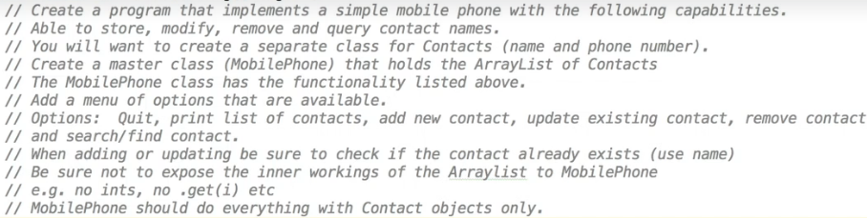  
* **One thing I wanna do which you may not have thought about, is we want to expose a PUBLIC STATIC method so that we can create a new contact record**. And this will be very useful when we are accessing the functions that are built into mobile phone. So instead of having to pass the parameter for the name and the phoneNumber, we can create a contact record. And we can also create it without creating a new separate object. And it’s really just a one-liner. STATIC is the important thing here because that means that we don’t have to create a new object instance for this contact class.  
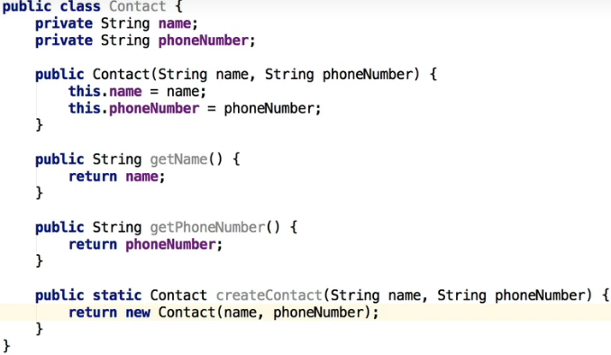

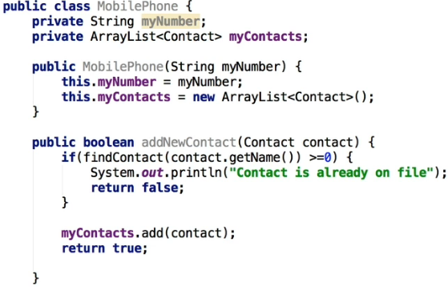  
 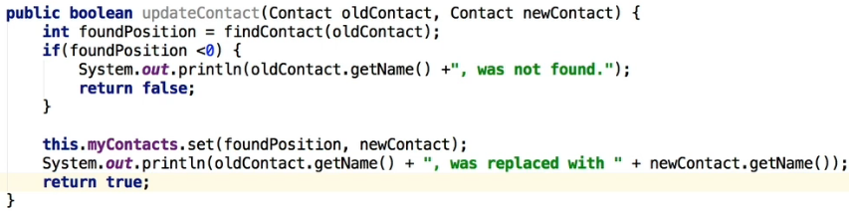  
 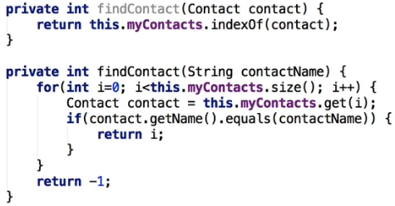

**ArrayList Challenge Part 2**  
* The 2 findContact() methods that are private use the index which is used for the Array so we don’t want them to be accessible from outside, let’s create another method which returns a String.  
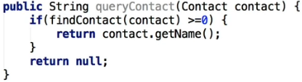  
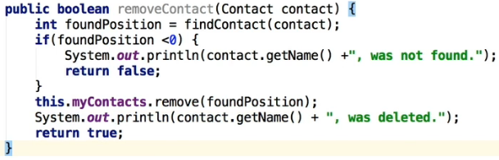  
* Let’s now test our code in the Main.java.  
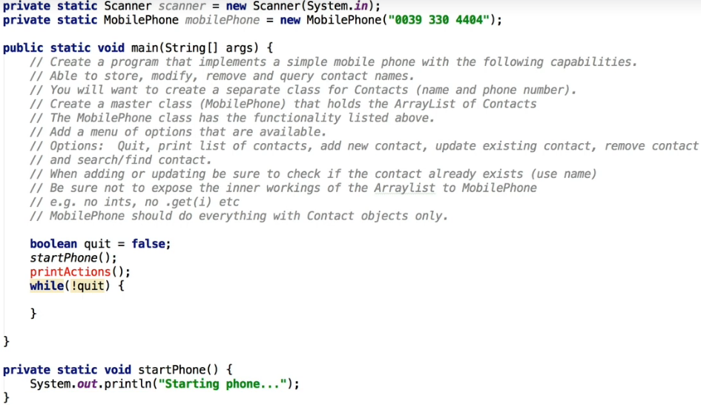  
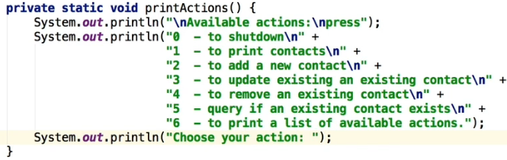  
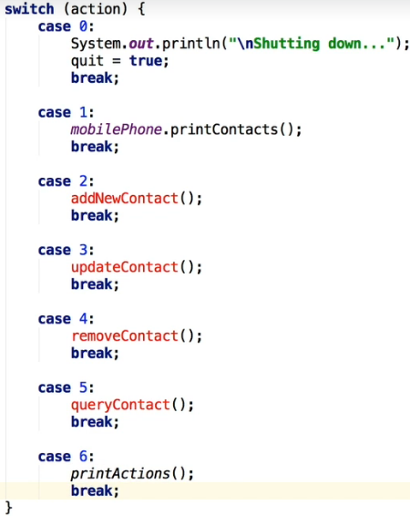  
* printContacts() => this does bring up an interesting question: should we implement the printContacts() by writing out all the code to go through the list of ArrayList entries here, or should we do it in the MobilePhone?  
=> **My argument would be that we wouldn’t be doing it here, in actual fact what we should be doing is implementing a printContacts function within the MobilePhone class itself**.   
=> **We don’t want the class or the code that’s calling the MobilePhone code to know how the underlying ArrayList works or even that there is an ArrayList in use**.

* In MobilePhone.java  
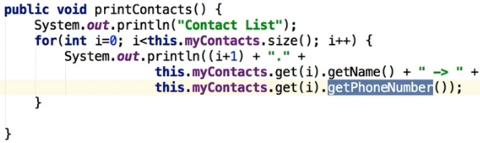  
* In Main.java  
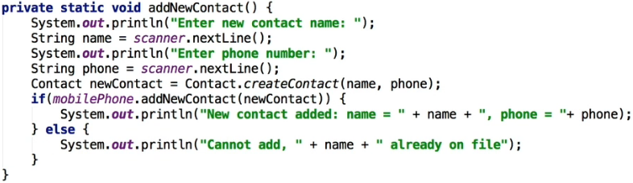  
* **The Contact.createContact(name, phone) could be called a Factory method as well**.  
=> **It’s just a simple way to create a new Contact record without having to create a new Contact class without necessarily having an instance/object to call a method on, that’s what the STATIC allows us to do**.

**ArrayList Challenge Part 3**  
* In MobilePhone.java  
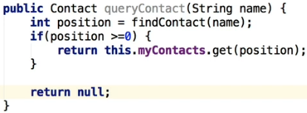  
* In Main.java  
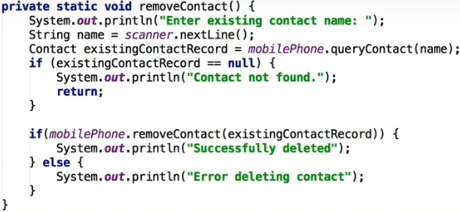  
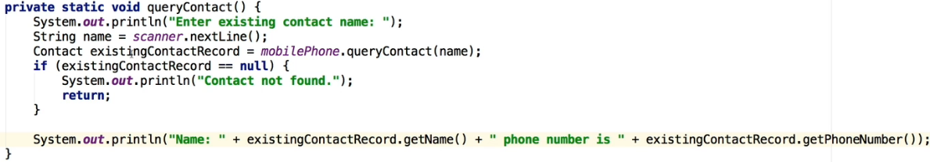  


**Bug Fix for ArrayList Challenge**  
* Currently we can update a contact with a name that already exists in the list.  
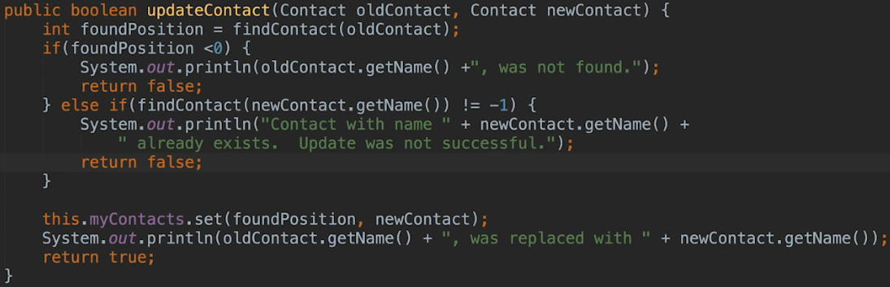

**Autoboxing and Unboxing**  
* We need a class to be able to save something to an ArrayList so we can’t have primitive types in an ArrayList.  
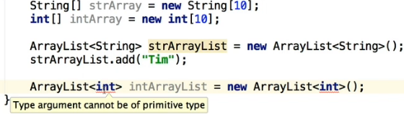

* We can do something like this:  
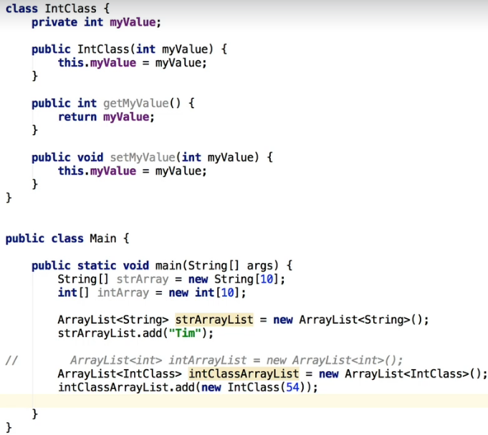  
* But it’s a little bit messy because there’s all this extra constructor code and getters/setters that we’d need to create to do that. **So it would be good if there was an easier way to do this and for all the primitive types if there was a way to actually use those as Objects**.  
=> That’s what **Autoboxing** is all about because Java does provide us with that functionality.  
* It’s like an **Object Wrapper**.  
* **Integer** **is actually a Class**. These exist for all the primitive types.  
* **Integer.valueOf(i)** => **takes an int and converts it into the Integer class**. **Autoboxing**.  
* **Integer.intValue()** => **converts it back to an int**. **Unboxing**.  
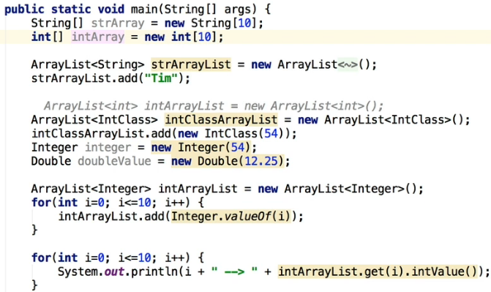  
* **There’s also a short way of doing this**:  
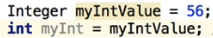 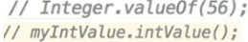  
* When the code is compiled, the `Integer .valueOf(56)` is executed or myIntValue.intValue().

* Without the shortcut.  
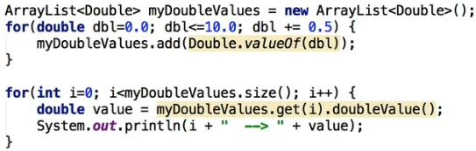  
* We can also use the shortcut.  
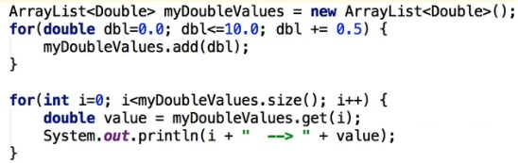

**Autoboxing & Unboxing (Challenge Exercise) - Part 1**  
* I’m going to start from the buttom, with the Customer, we need it to do anything else anyway.  
* **Customer**  
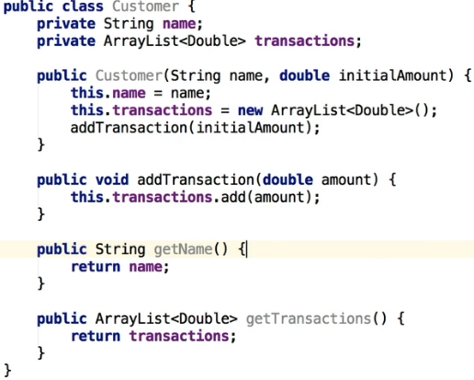

* **Branch**  
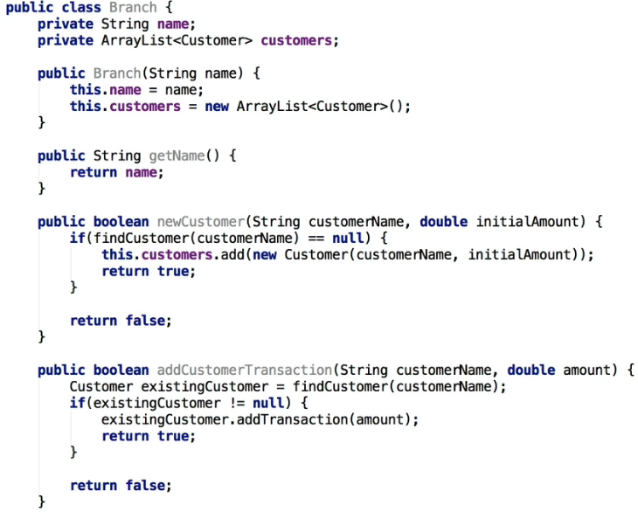  
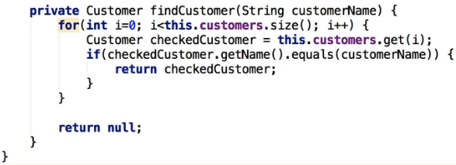

**Autoboxing & Unboxing (Challenge Exercise) - Part 2**  
* **Bank**  
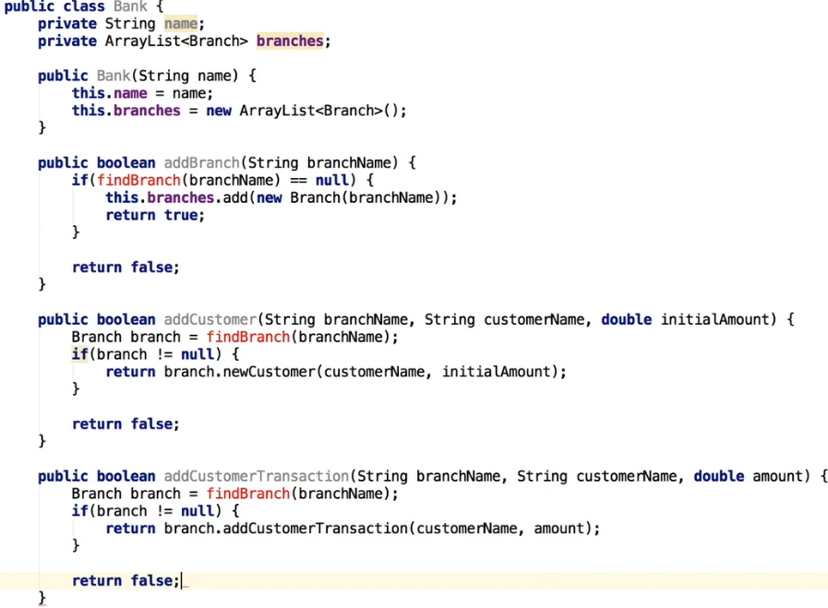  
* addCustomer() => we’re checking to see first whether the branch exists and then we’re leaving the check to see whether the customer can be added to the appropriate class. So we’re actually calling the branch code to do the checking in there. So you can see how we’re separating the data validation into the right areas, so we’re not putting huge amounts of data validation in one spot. **This is one of the keys to OOP, to make sure you’re trying to validate only a specific thing in a specific area and therefore your code is more compact and more along the lines of a black box functionality and it’s easy to maintain because it’s fewer lines of code and just really easy to understand as well**.  
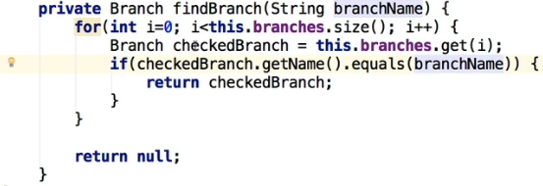  
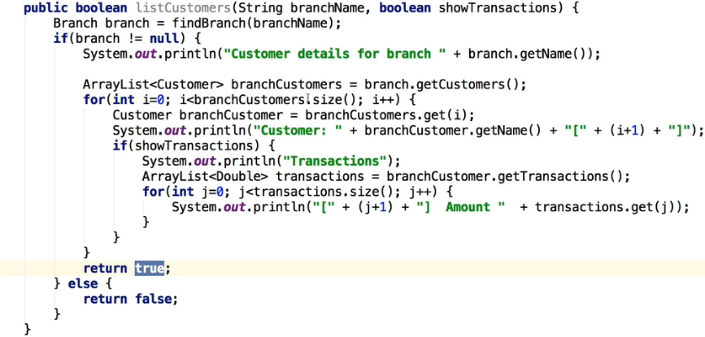  
* We’ll need to create a getter for customers in Branch.java.

**Autoboxing & Unboxing (Challenge Exercise) - Part 3**  
* In Main.java  
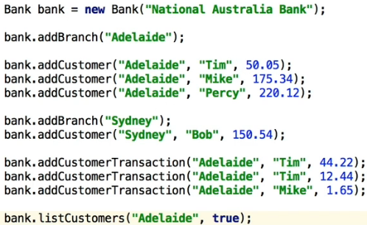 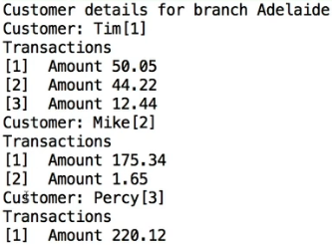

**LinkedList Part 1**  
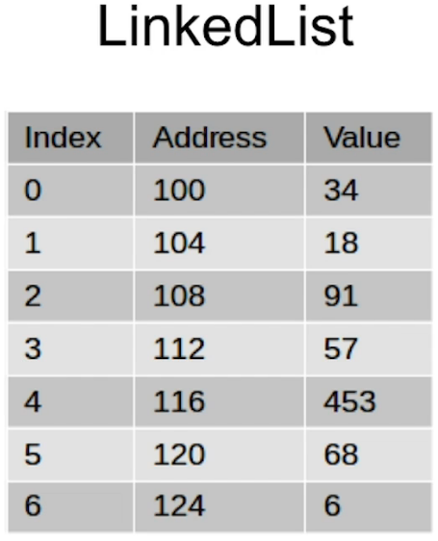  
* What happens internally - and this is important to get a good understanding of LinkedLists - is that Java will automatically allocate 4 bytes of memory for each integer. Because it needs up to that amount to be able to store the highest value integer.  
* So you can see what happens there is that Java will try to do this contiguously so you can see in this case there’s actually a formula that Java can use to actually figure out which address - which physical memory address to use to grab the value.  
* So what it can do quite simply - it can look at the base address - this is actually for the first element in the array, so it would be the position index 0. So you can actually use that formula and calculate the actual address based on that. So in other words looking at the base address which in this case is 100 + 4 x index number. So third position would be: 100 + 4 x 3 = 112.  
* So that’s how Java sort of handles things internally and this type of thing works for Primitive Types much the same way. For double it uses up to 8 bytes because it needs that for the floating point numbers. The same formula would apply, we’d just multiply by 8 instead of 4.  
* So that works fine for Primitive Types where you’ve got a known value and it’s always gonna be the same length. For example integers will always consume 4 bytes of memory.  
* What about strings and Objects in general?   
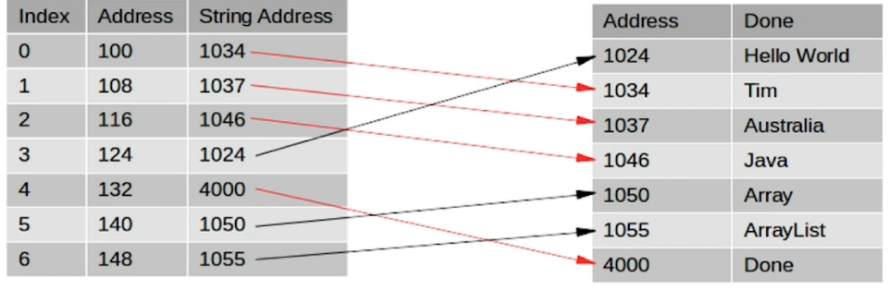  
* The memory that’s being allocated in the array is actually itself 8 bytes but that actually points to another location in memory where the string is. So consequently by doing that, Java can actually keep track of the actual strings that are in the array and also the strings can each be a variable length, so they can be different lengths because of course strings can be a variable length unlike an integer which is always 4 bytes.  
* So you can see: Array, index position 0 which is at a memory location 100, it’s got a String address of 1034 and then, looking at the memory address of 1034, it’s actually got the string value, in this case of Tim.  
* If we printed that out, the actual order thata would come out is: Tim, Australia, Java, Hello World, Done, Array, ArrayList because of course it’s going through the index positions 0 - 6.  
* The other thing to note is, with all these strings over there to the right hand side, once your program stops executing, or goes out of scope in some way, and then the variables are no longer needed, there’s this process called **Java’s Garbage Collection** which goes through automatically and frees up that memory, so it releases it so it can be used again. That again has all been happening behind the scenes and it’s not something you need to worry about.  
* And just a final point here to make is that the actual string addresses do not need to be contiguous, so in other words you can see here that one of the string address here for index position 4 is actually address 4000, but some of the other ones have got completely different numbers. So the point here is that things can be completely different, and that’s the way it happens and it’s done internally by Java.  
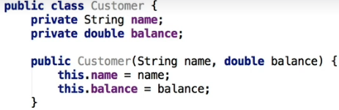  
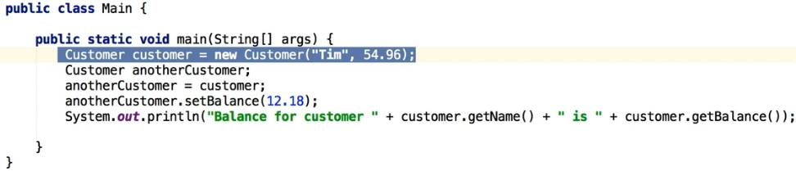  
  
* What actually happens is when we do this assignment, `anotherCustomer = customer`, what Java was doing internally is assigning the second customer class to point to the first class. So in other words it just saved the memory adddress. It didn’t create a separate class. So as a result of only saving the memory address, when we used the setBalance() command, it actually saved the value in this original location. So for all intents and purposes, there’s only 1 class here. The anotherCustomer is just pointing to the customer. That’s all because of how memory is used and allocated within Java.  
* So if Java doesn’t let us use pointers, in other words we can’t actually point to these objects directly, why are we discussing them? It’s important to understand all this before we can understand what a LinkedList is and the advantages that it can give you over an Array.  
* **.add(1, 2)** inserts the number 2 in the index position 1.  
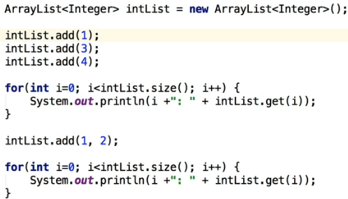 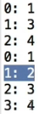  
* In order for that to be inserted, the other entries had to be moved down to make space for this new entry.  
* Now that is not a big deal in terms of computere processing time when we’re dealing with a small Array as you can see on the screen here.   
* But when we actually start talking about an Array containing thousands, perhaps millions of existing records/items, it’s gonna get a lot slower to process, it’s a lot more work the computer has to do because there’s just so many more records/items to process.  
* And similarly, if you have to remove an item from an Array, what actually has to happen is all the other items have to be moved up to fill the gap.

* **LinkedList** is an alternative to Arrays and it’s really useful in some situations. How it works is it actually stores the actual **LINK to the next item** in the list as well as the actual data. In other words each element in the list actually holds a link to the item that follows it, as well as the actual value you’re wanting to store as well.  
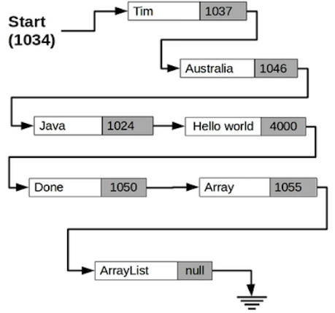  
* So if we created a LinkedList like this, we could literally iterate through the lists of items in it. We could start on the first one, and that code would be checking to see whether the link is linking to anything, if it does, we pick up the string, store that location and actually save that so in that case if you’ve got a LinkedList like this we can literally iterate through the items in it.  
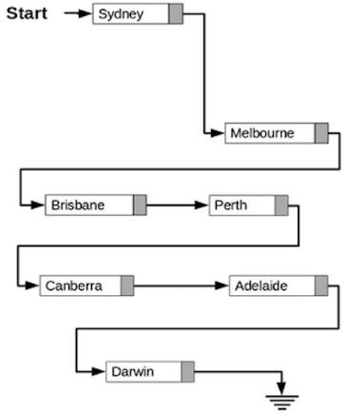 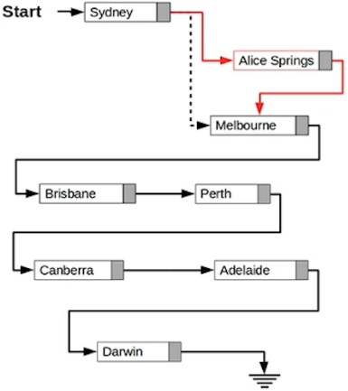  
* In a normal Array you’d need to move all the elements down.  
* In a LinkedList that’s so much easier, no elements needed to be moved down at all. We just created a new entry “Alice Springs”m we point it to where “Sydney” used to point to and then we set “Sydney” to point to “Alice Springs”. Therefore we can still go through that list and get all the records that way.  
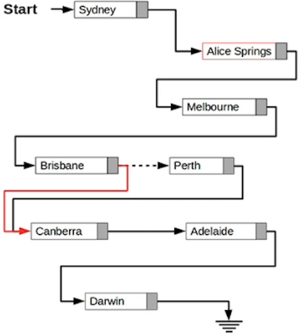  
* We can remove elements the same way.  
* **“Perth” is still pointing to “Canberra” but because nothing is pointing to “Perth” anymore, the object will be automatically destroyed by Java during its Garbage Collection**.

**LinkedList Part 2**  
* In IntelliJ if you want a main method so that you can actually execute it, there’s a shortcut:  
**psvm + tab**  
* **Iterator** is **another way of accessing and going through all entries**.  
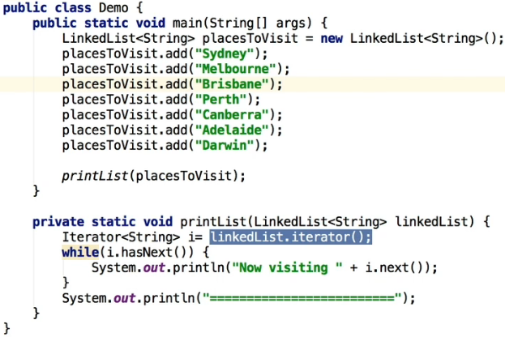 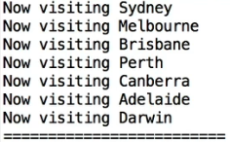  
* .next() => returns the current value before moving to the next item.  
* .hasNext() => returns if there is another item.   
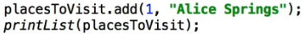 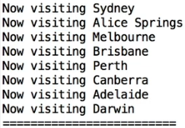  
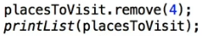 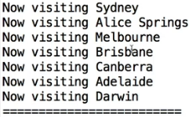

* With this mechanism if you have thousands of records, there’s not really gonna be any slowdown in performance because it’s literally only changing one or two entries at the most, everything else remains in the same position.  
* **Let’s now see the advantages of a LinkedList**.  
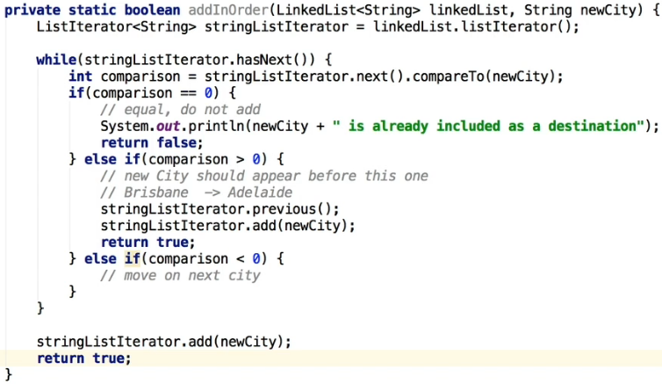  
* We want to have an alphabetical order. Also we don’t want to allow duplicates.  
* We’re gonna use something similar to an Iterator.  
* **ListIterator** gives you more flexibility, it’s really made for situations like this where we’re inserting records and stuff like that.  
* **.compareTo()** => **gives us a number, if it’s a 0 it means they match**.  
* **.previous()** => **goes back to the previous item**.  
* **With a regular Iterator you can’t go to the previous item**.

**LinkedList Part 3**  
* **The line where you create the ListIterator is not actually pointing to the first record yet, so you actually have to use a stringListIterator.next() to go to the first record**.  
* Now I just wanna make a point that writing methods with side effects - such as using .next() is generally to be avoided. **So unless you really know what you’re doing, it’s not a good idea to write a method that both returns a value and changes the Object that it’s called from**. That’s what’s happening in our method - we’re returning true/false but we’re also modifying the LinkedList that was passed to the method, we’re actually changing the actual entries. So generally speaking, you don’t wanna do it that way.  
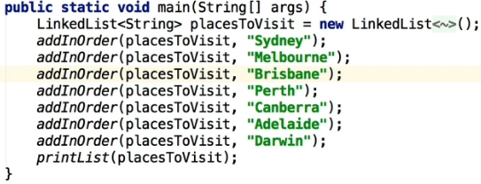 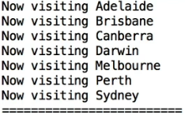  
* **LinkedLists are perfect when you’re inserting records on regular basis or sort things**.  
* **Java implemented the LinkedList as a DoubleLinkedList**.  
* **.getFirst()** **get’s the first item in the LinkedList**.

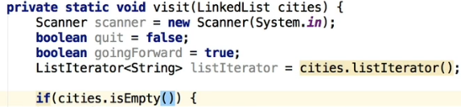  
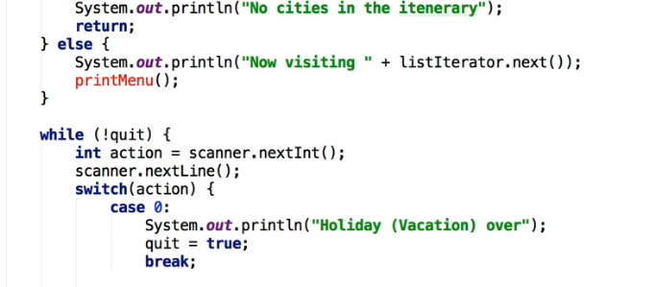  
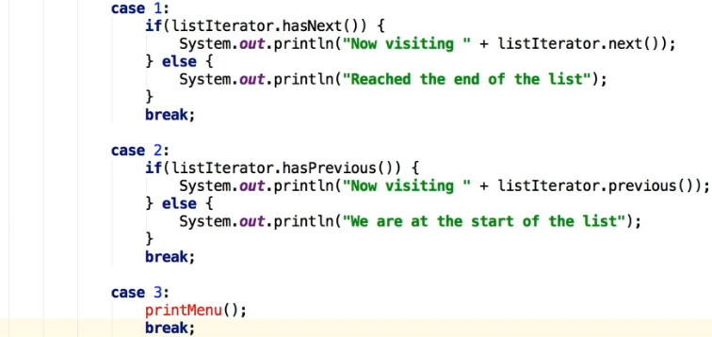  
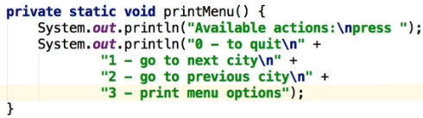  
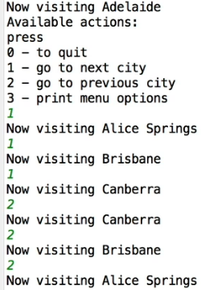  
* If we try to go back, you see there is a problem - the problem is that Java doesn’t implement the LinkedList in quite the way that we’ve actually described. There’s actually an explanation of the ListIterator I wanted to show you that on the screen to help you understand how this actually works.  
* The problem actually is that there’s no current position as such.  
  
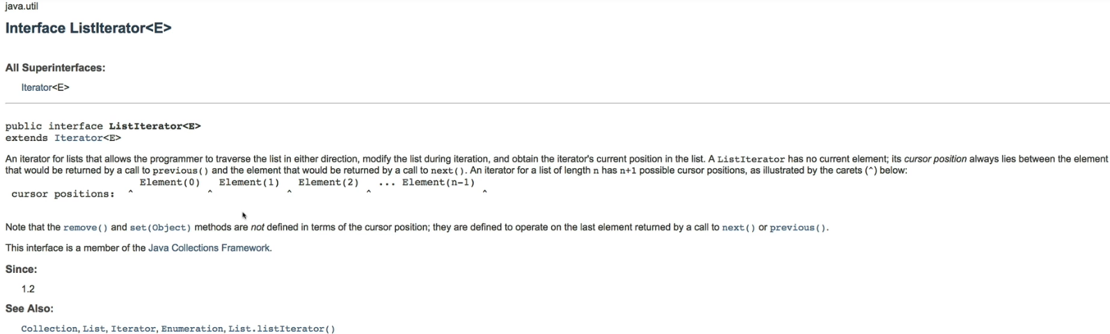  
* So the ListIterator actually hovers between the items that would be returned when you go to previous or next. So if you go forward with one and then go back with two, then go forward with one, you never actually leave the city that you’re actually in. This is actually a problem.  
* But there is a good reason for this. If you actually allowed access to the item at .next or .previous in the normal way, then an error would actually lead to loops in the list. For example if we made a mistake where we’re moving Perth from the list, we’d end up with something like this:  
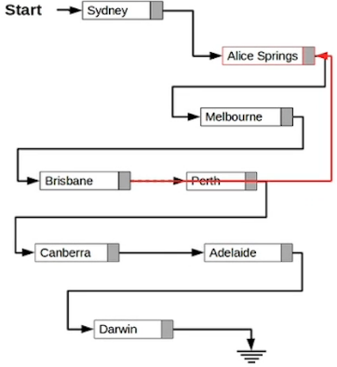  
* So in this scenario, if I had left it how you would think it would normally work, then traversing in this would then return Sydney, Alice Springs, Melbourne, Brisbane, Alice Springs, … sort of like an infinite loop, and of course, we don’t want that to happen. So this is like a really sufficiently serious problem in the past that algorithms have been developed for detecting and fixing loops in structures like LinkedLists. So you can google something like: Tortoise and the Hair Algorithm. You’ll see that there’s actually a big issue with that.  
* But the great thing is that Java set it up in such a way, that that is not going to happen to you. So it doesn’t really allow you to make that type of mistake where you’ll get into a loop. What it does mean is we need to keep track of which direction we’re going and allow ofr the inbetween nature of the iterator.

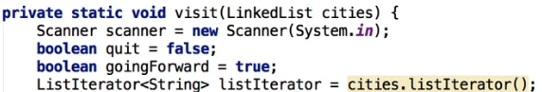  
* Added goingForward.  
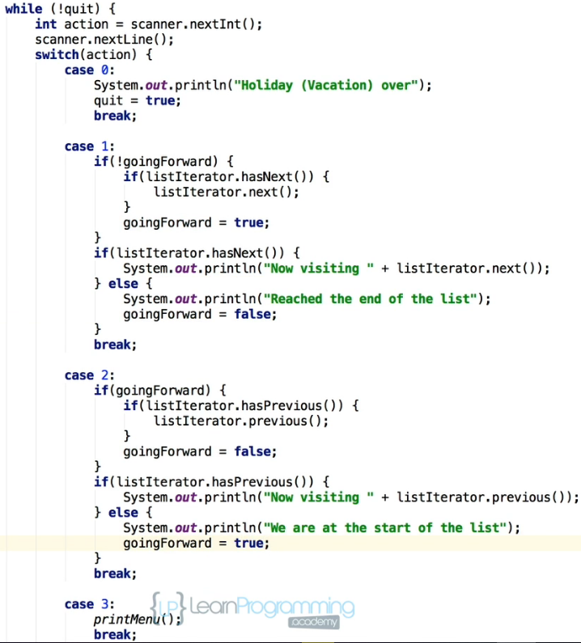  
* So we basically had to add an extra check, an extra .next() and .previous() that you need to use if you’re moving from one direction to another.  
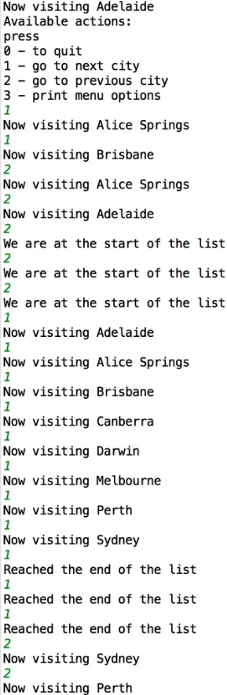

**LinkedList Challenge Part 1**  
* .toString() is just a quick way to actually output the contents of an Object. It’s part of the Java infrastructure for all Objects.  
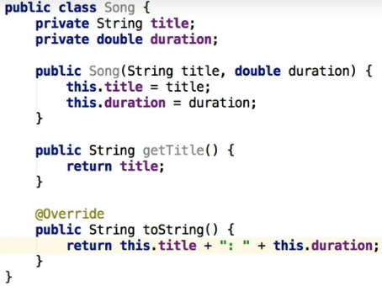  
* **FOR EACH command** => **Alternative way to actually go through a list of entries**. It’s easier to read.

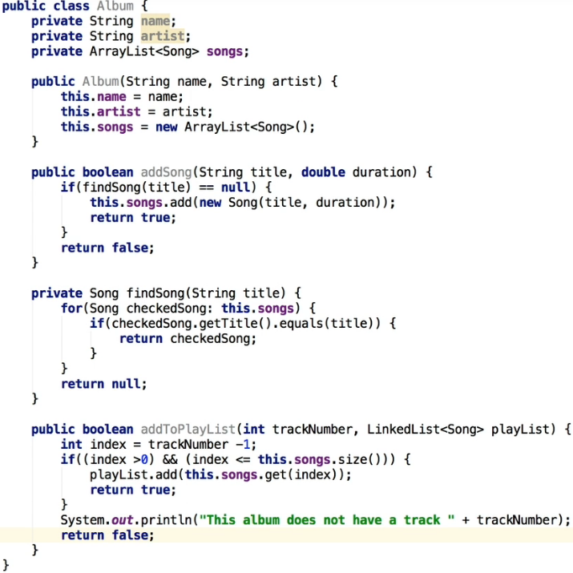  
* Let overload the addToPlaylist() method to have an option to add a song by passing the title only.  
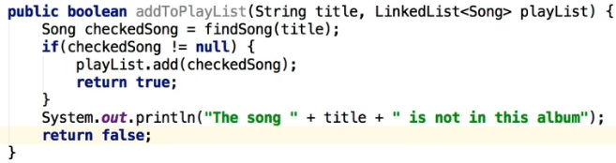  
* There’s 1 mistake:  
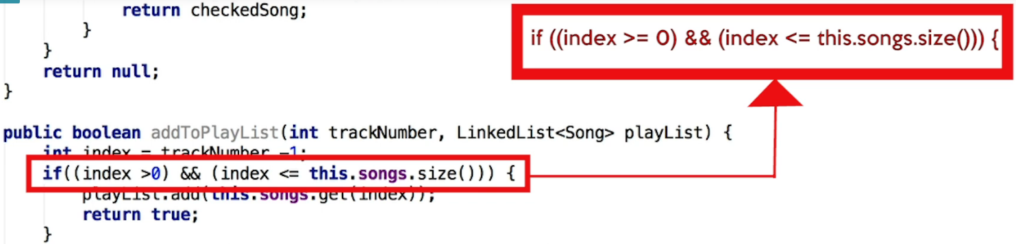  
* **We could’ve added the addToPlayList() in the actual Song object itself**.  
* But I chose to have it in the Album because we’re actually looking at the Album when we’re creating the Playlist. But it would be equally valid if you decided to have that code in the Song class.

**Bug Fix for “Track 1” Error**

**LinkedList Challenge Part 2**  
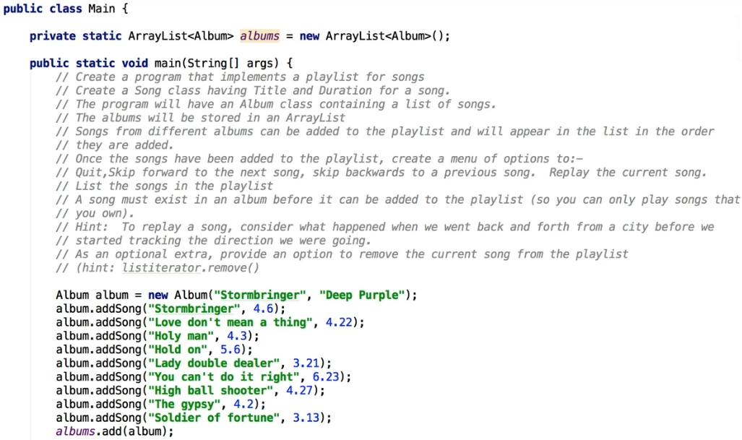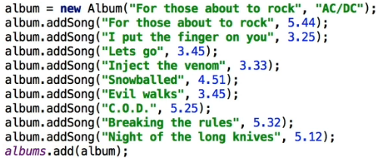  
* We can use album again because by creating a brand new Object, it’s going to be completely different to the previous album object that we created above.  
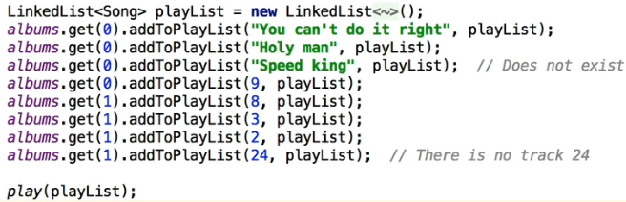

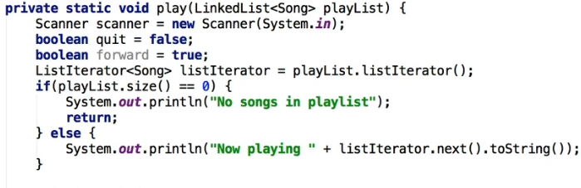  
 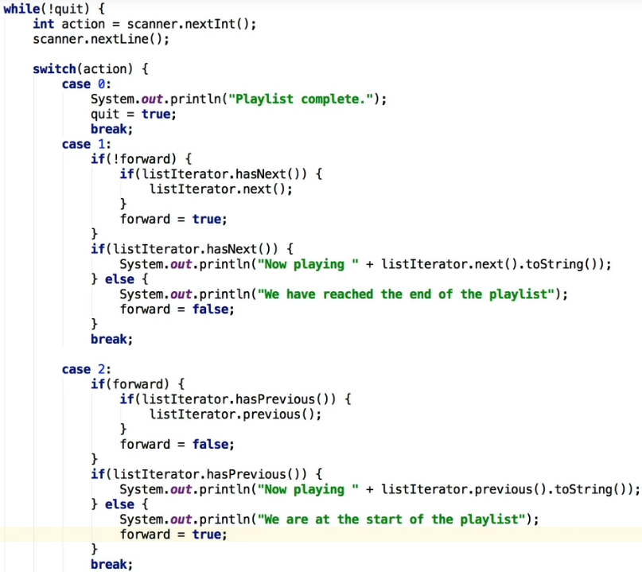

**LinkedList Challenge Part 3 (Final Video)**  
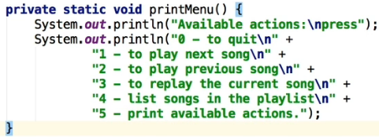  
* We don’t need to go backwards and forwards so I’m gonna show you how to use a regular Iterator.  
* **We could use .toString() but it’s actually a default option**.  
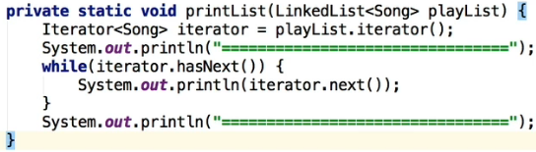

* To be able to replay a song, we can take advantage of the fact that the ListIterator is actually somewhere between the previous and the next, in other words somewhere in the middle.  
* All we really need to know is which direction we were moving in at the time.  
* For example if we’re moving forward, we’re just after the currently playing song so we need to go back because we’re in a forward position. But if we’re actually going backwards, we would be going to the previous one, then we’re just before the current song so we need to go forward.  
* So in both cases we’ve changed the direction, so we need to set forward appropriately. So if we’re going forward and go back to play the same track again, and then forward, and also vice versa.  
  
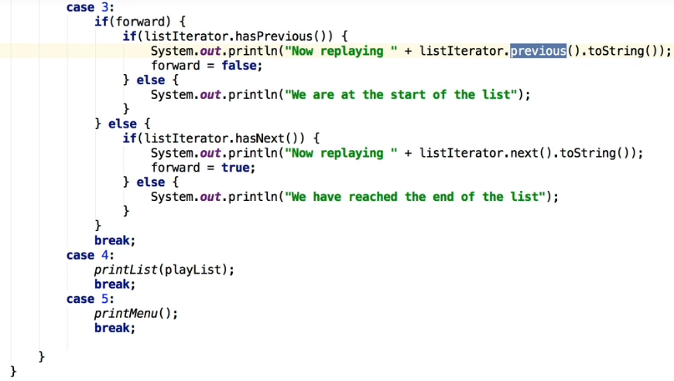

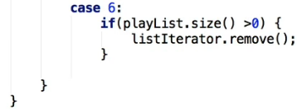  
* There’s a potential issue with this.  
* The actual issue here has to do with the way that ListIterator is actually set up, the LinkedList.  
* **It can only be made once per call to .next() or .previous() so it actually throws and exception if nether the .next() or .previous() has been called. So in other words, each time you delete a record, you then have to do a .next() or .previous()**.  
* We can trap those Exception errors using a **TRY** **CATCH** block.  
* Since we haven’t talked about Exceptions, an alternative way to fix this issue is to ensure we call either .next() or .previous() immediatelly after removing a song.  
